Name:Whail Bin Sharif

Roll No :BSEF17A554

OS LAB 01

BASIC SHELL COMMANDS

Task 1

With help of whoami



Task 2:

Using touch testingFile

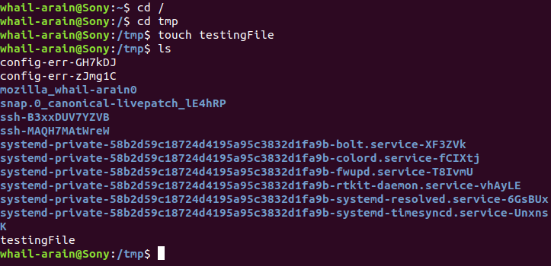

Task 3:

Using file FileName

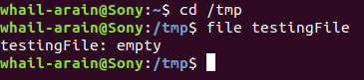

Task 4

Rm to delete a file while rm -r to delete a occupied directory and rmdir to delete an empty directory

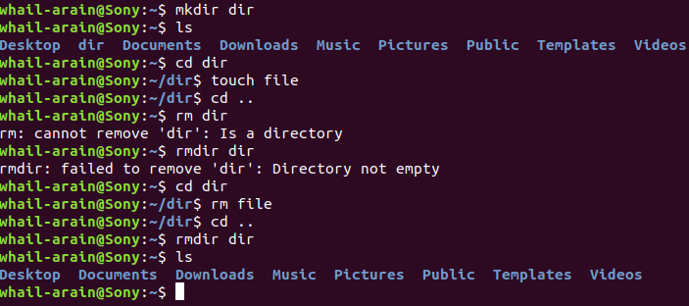

Task 5



Task 6

Mv to rename a file from tryit& to tryit_now

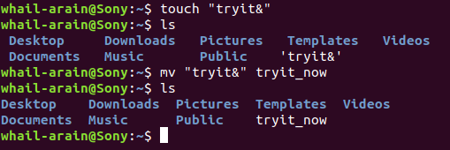

Task 7

Alias myclear=clear to give another name to clear command

Task 8(a)

Output will be showing of directories present in the home

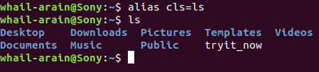

Task 8(b)

Output will be that we can’t create directories with same name

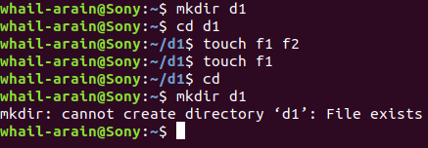

QUESTIONS(2)

Task 1

Mkdir /tmp/BSEF17A554 /tmp/BSEF17A554/WhailArain /tmp/BSEF17A554/WhailArain/OS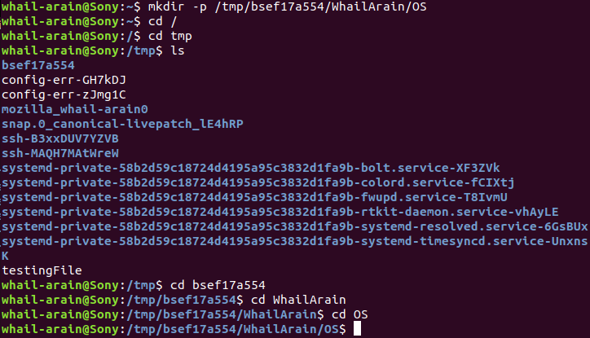

Task 2

Ls -al to display hidden files

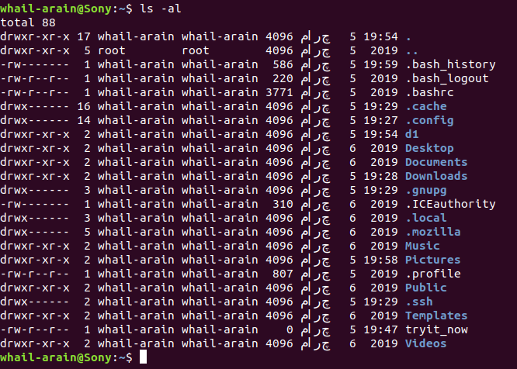

Task 3

Rm -r/tmp/BSEF17A554 to delete directories and their respective sub directories and rmdir /tmp/BSEF17A554/WhailArain/OS /tmp/BSEF17A554/WhailArain /tmp/BSEF17A554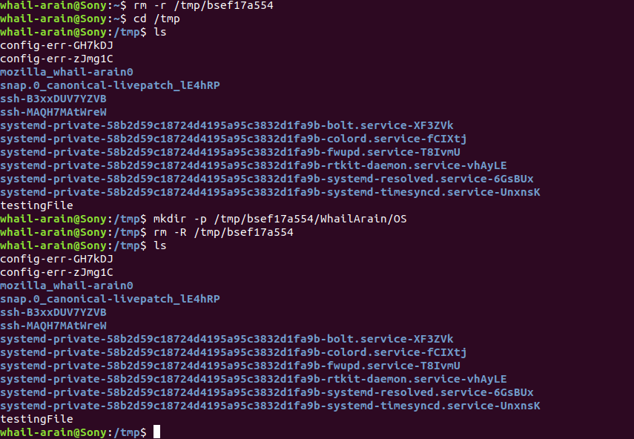

Task 4

Cat > testFile to write files & cat -n testFile to check no of lines with text

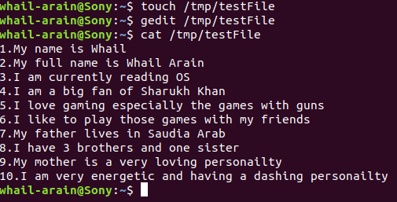

Task 5

Mv testFile test@File to rename and no it doesn’t exist anymore

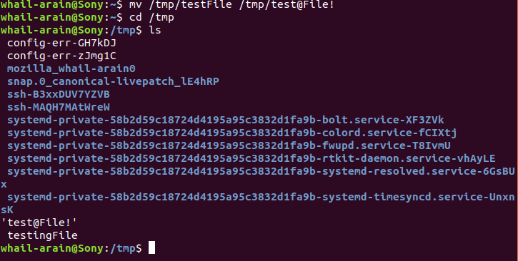

Task 6

Tail -2 testFile to display last 2 lines of file

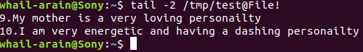

Task 7

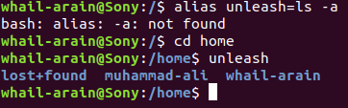

Task 8

Use man “command name” e.g

man clear .Can’t display all of it as it shows much amount of manual



Task 9

Type type shows it’s a builtin so it is a internal Command



TASK 10

Rm -r directory name to remove directory

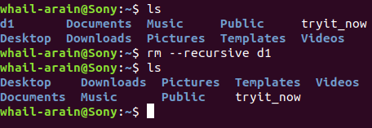

QUESTIONS

Absolute Path

Task 1

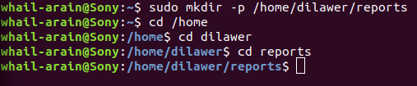

Task 2

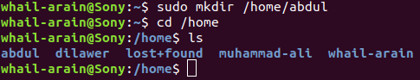

Task 3

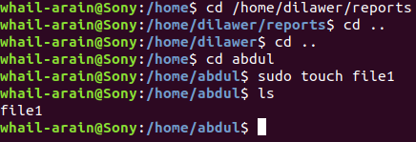

Task 4

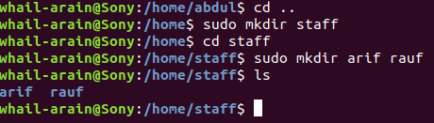

Task 5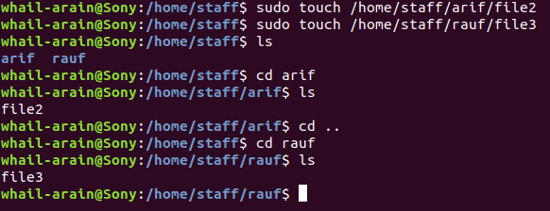

Task 6

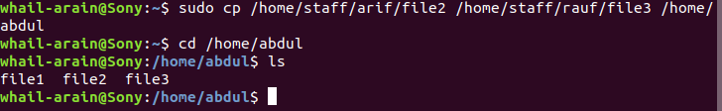

Task 7

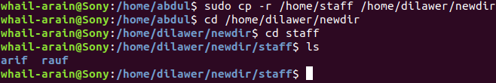

Task 8



Task 9

